ADDRESS RESOLUTION PROTOCOL

sudo wireshark -i wlp2s0-k -Y “arp”

→ This opens wireshark and apply arp as filter and start capturing arp packets

ARP – Address Resolution Protocol

To generate ARP TRAFFIC → ping <ip-address>

Analysis of ARP packets:
- ARP Request Structure:
  - Sender MAC Address: MAC of the requesting device
  - Sender IP Address: IP of the requesting device
  - Target MAC Address: 00:00:00:00:00:00 (unknown)
  - Target IP Address: IP of the requested device
- ARP Reply Structure:
  - Sender MAC Address: MAC of the responding device
  - Sender IP Address: IP of the responding device
  - Target MAC Address: MAC of the requesting device
  - Target IP Address: IP of the requesting device

Role of Sender’s IP and MAC Address:
- The sender’s IP address in an ARP request identifies the device making the request.
- The sender’s MAC address is used by the receiving device to update its ARP table.
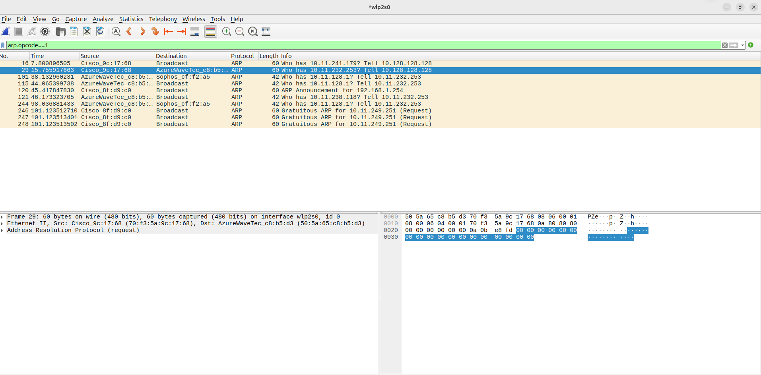
- In an ARP reply, the sender’s MAC address is crucial for allowing communication between devices.

The source MAC (70:f3:5a:9c:17:68, Cisco) is sending an ARP Request to the destination MAC (94:e2:3c:36:01:3c, Intel).
- The ARP request is asking "Who has 10.11.238.118? Tell 10.128.128.128".
- This means the sender (10.128.128.128) is trying to resolve the MAC address of 10.11.238.118.
ARP PACKET = ETHERNET + ARP
Ethernet II Frame (layer 2)
Source MAC 70:f3:5a:9c:17:68 (Cisco)
Destination MAC FF:FF:FF:FF:FF:FF (Broadcast)
EtherType 0x0806 (ARP)

ARP (Layer 3)
Hardware Type 1 (Ethernet)
Protocol Type 0x0800 (IPv4)
Hardware Size 6 (MAC length)
Protocol Size 4 (IPv4 length)
Opcode 1 (ARP Request)
Sender MAC 70:f3:5a:9c:17:68 (Cisco)
Sender IP 10.128.128.128
Target MAC 00:00:00:00:00:00 (Unknown)
Target IP 10.11.238.118 (0x0A808080)

Reply Packet Breakdown
1.Ethernet II Frame:
- Source MAC: 94:e2:3c:36:01:3c (Intel device)
- Destination MAC: 70:f3:5a:9c:17:68 (Cisco device)
2.ARP Protocol:
- Opcode: Reply (0x0002)
- Sender MAC Address: 94:e2:3c:36:01:3c (Intel)
- Sender IP Address: 10.11.238.118
- Target MAC Address: 70:f3:5a:9c:17:68 (Cisco)
- Target IP Address: 10.128.128.128

